**List of Tools and Equipment (Trade Wise)**

**1.1 List of equipment for each course:**

Following are details of equipment available for different courses:

1. **Computer Labs details:**
2. Computer Lab No. 01 having 25 Computers with allied facilities
3. Computer Lab No. 02 having 25 Computers with allied facilities
4. Computer Lab No. 03 having 25 Computers with allied facilities
5. Class Room No.01 (Theory)
6. Class Room No.02 (Theory)
7. Class Room No.03 (Theory)
8. Class Room No.04 (Theory)
9. Principal & Admin Office
10. Reception & Placement Office
11. Library
12. Store

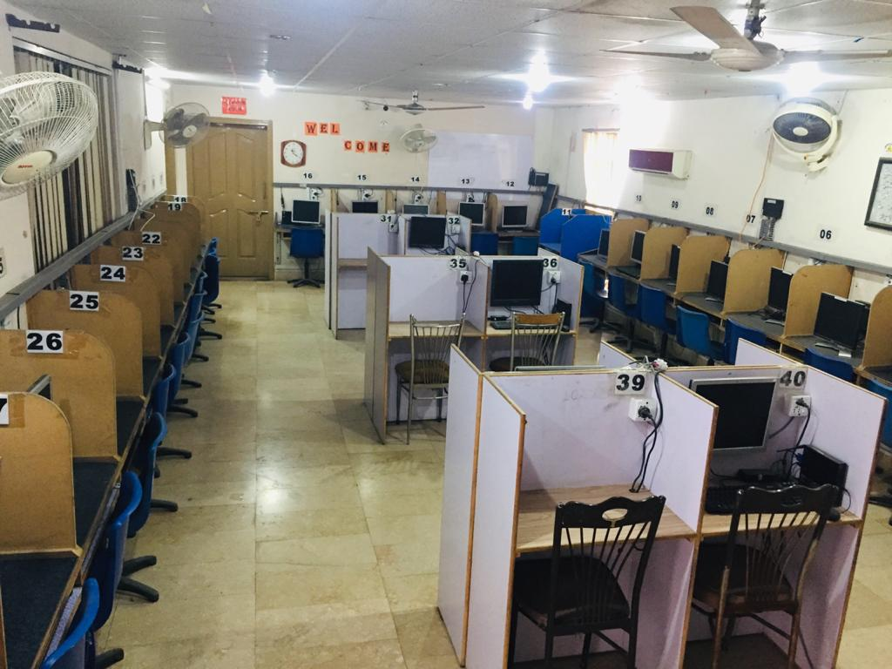

Photo here

**Computer Lab No. 01 having Computers with allied facilities**

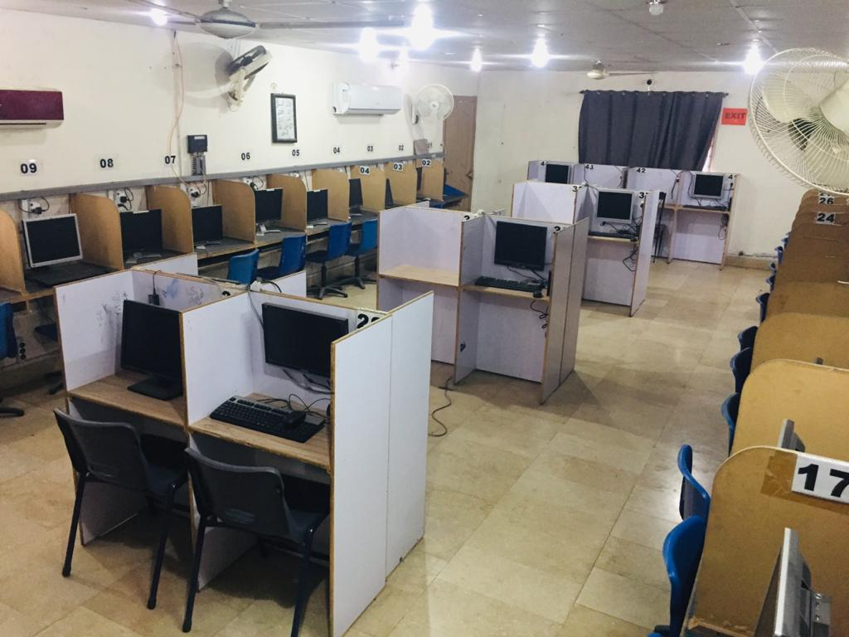

Photo here

**Computer Lab No.02 Having Computers with allied facilities**



Photo here

**Computer Lab No.03 Having Computers with allied facilities**

1. **Web and Graphic Designing**

| **Sr. No.** | **Tool/Equipment name** | **Equipment Present** |
| --- | --- | --- |
| 1 | Computer System (Complete with all accessories) As per specifications notified by NAVTTC | 25 |
| 2 | 5 KV A UPS with Batteries | 4 |
| 3 | AC Split 02 Tons | As per Lab.size |
| 4 | Multimedia Projector with screen, as per specifications notified by NAVTTC | 1 |
| 5 | Digital CameralDSLR | 1 |
| 6 | White board | 1 |
| 7 | Display Board | -1 |
| 8 | LaserJet black printer A4/Legai as per specifications notified by NAVTTC | 1 |
| 9 | Networking with Internet connection 08 Mbps with Router | 1 |
| 10 | Scanner as per specifications notified by NAVTTC | 1 |
| 11 | Computer Table | 25 |
| 12 | Computer Chairs | 25 |
| 13 | Teacher chair | 1 |
| 14 | Teacher table | 1 |
| 15 | Head Phones with Mic | 25 |
| 16 | Software Adobe Photoshop CC latest | 1 |
| 17 | Software Corel draw CC latest | 1 |
| 18 | Software MS Office 2013 | 1 |
| 19 | Software Camtasia | 1 |
| 20 | Set Square | 25 |
| 21 | Pencil | 30 |
| 22 | Rubber | 30 |
| 23 | Pencil Sharpener (small and portable) | 4 |
| 24 | Flip Charts | Different types and |
| 25 | Paper Cutter | Nos.50 |
| 26 | Crepe Paper | 30 |
| 27 | A4/Legai Rim 809m | 10 |
| 28 | File Folder | 5 |
| 29 | Note pad | 30 |
| 30 | Ball Point | 30 |
| 31 | Board Marker | 30 |
| 32 | Permanent Marker | 1 Pack |
| 33 | UHU Gum stick | 12 Different Colors) |
| 34 |  | 12 |

1. **E-commerce**

## Tools and equipment

(Anticipated Class size: 20 trainees/students, it may vary)

|  |  |
| --- | --- |
| 20 copies per class | Text book(s) for this course |
| 20 copies per class | Reference book(s) for this course |
| 20 copies per class | Syllabus for this course |
| 1 class set | Bio-Sketch of Trainer |
| 5 copies per class | Directories of E- business companies |
| 1 completed class copy as example 20 blank copies | Examples of business plans |
| 1 completed class copy as example 20 blank copies | Examples of Technical plans |
| 1 class set | Advertising materials for E-Business promo |
| 1 class set | Copies of job advertisements extracts |
| 1 class set | Information on sources of Knowledge Management |
| 1 completed class copy as example 20 blank copies | Business planner templates |
| 1 completed class copy as example 20 blank copies | Start-up-time estimator |
| Contact details for colleagues, supervisor | |

**Tools and Equipment**

(Class size: 25 trainees/students)

|  |  |
| --- | --- |
| 1 set | Fire equipment, including the provision of fire exits, fire doors, fire extinguishers, alarm systems, emergency lighting, fire safety and exit signs |
| 1 set | Computers, Scanner, Printer, Multimedia Projector, Microphone, Speakers, Reliable Public Internet Connectivity |
| 1 set | Software   * Visual Studio.Net (any version) OR Visual Web Developer (any version) * PHP (any version) * MySQL and SQL Server (any version) * Macromedia Dreamweaver (any version) * Adobe Photoshop (any version) * Microsoft FrontPage & Microsoft Publisher (any version) * Microsoft Office (any version) * ECM tools (any) |

## Computer Business Management / IT (Office) Assistant

**Tools and equipment**

**Documents, policies and guidelines**

|  |  |
| --- | --- |
| (Anticipated Class size: 20 trainees/students, it may vary) 20 copies per class | Text book(s) for this course |
| 20 copies per class | Reference book(s) for this course |
| 20 copies per class | Syllabus for this course |
| 1 class set | Bio-Sketch of Trainer |
| 5 copies per class | Directories of Business companies (Yellow Pages) |
| 1 completed class copy as example 20 blank | Examples of business plans |
| copies |  |
| 1 completed class copy as example 20 blank copies | Examples of Technical plans |
| 1 class set | Copies of job advertisements extracts |
| 1 class set | Information on sources of Knowledge Management |
| 1 completed class copy as example 20 blank copies | Business planner templates |

## Web Design and Development

|  |  |
| --- | --- |
| 20 copies per class | Text book(s) for this course |
| 20 copies per class | Reference book(s) for this course |
| 20 copies per class | Syllabus for this course |
| 1 class set | Bio-Sketch of Trainer |
| 5 copies per class | Directories of E- business companies |
| 1 completed class copy as example 20 blank copies | Examples of business plans |
| 1 completed class copy as example 20 blank copies | Examples of Technical plans |
| 1 class set | Advertising materials for E-Business promo |
| 1 class set | Copies of job advertisements extracts |
| 1 class set | Information on sources of Knowledge Management |
| 1 completed class copy as example 20 blank copies | Business planner templates |
| 1 completed class copy as example 20 blank copies | Start-up-time estimator |
| Contact details for colleagues, supervisor | |

|  |  |
| --- | --- |
| 1 set | Fire equipment, including the provision of fire exits, fire doors, fire extinguishers, alarm systems, emergency lighting, fire safety and exit signs |
| 1 set | Computers, Scanner, Printer, Multimedia Projector, Microphone, Speakers, Reliable Public Internet Connectivity |
| 1 set | Software   * Visual Studio.Net (any version) OR Visual Web Developer (any version) * PHP (any version) * MySQL and SQL Server (any version) * Macromedia Dreamweaver (any version) * Adobe Photoshop (any version) * Microsoft FrontPage & Microsoft Publisher (any version) * Microsoft Office (any version) * ECM tools (any) |

## Virtual Assistant (for Amazon)

Duration of Course (3-Months)

|  |  |  |
| --- | --- | --- |
| **Sr. No** | **Tools/Equipment** | **Quantity** |
| 1 | Desktop computer (specifications must be as per course requirement) | 26  (1 for each student & 1 for the teacher |
| 2 | Printer (Laser) | 01 |
| 3 | Scanner | 01 |
| 4 | Internet Connection (At least 5- MB speed | 01 |
| 5 | UPS for each system | 01 |
| 6 | Air Conditioner 1% Ton or 2 Ton | 02 |
| 7 | Multimedia Projector | 01 |
| 8 | Wireless Access Point/Router: (300 Mbps with minimum 4 Ethernet Ports, 10/100/1000 Mbps) | 01 |
| 9 | Mouse Pads | 26 |
| 11 | Design & programming software's   1. Operating System (MS Windows 7) for workstation 2. MS-Office 2010 3. M Adobe Photoshop 4. IV Drivers for all Hardware devices | One CD each software/ As per Requirement |
| 12 | Computer Chairs | 25 |
| 13 | Computer Tables | 23 |
| 14 | Important Tools for Product Research:  Jungle Scout, Merchant words, Helium 10, seller tools, Viral Launch. | 25 |